- RULES: All races will be governed by the rules as defined in The Racing Rules of Sailing 2013 – 2016 published by the United States Sailing Association, and by the HRYRA Cruising Fleets 2013 Common Sailing Instructions, all as modified by these instructions. Changes in these instructions, and other official notices, will be posted on the Boathouse Bulletin Board. Notices posted at least one hour before the start of the affected event shall be deemed notification to all participants.
- PHRF Certificates: The PHRF Certificate requirement of Section 1.3 of the HRYRA Cruising Fleets 2013 Common Sailing Instructions does not apply to the Open fleets or to any one-design fleet.
- VHF RADIOS: Each boat shall monitor VHF channel 72 for Race Committee Notifications. Errors in VHF transmissions shall be disregarded.
- STARTING AND FINISHING:
- The Start/Finish line is between the pole flying the Race Committee flag on the Race Committee Boat and a nearby floating mark…..***see race course details*** Racing will take place south of the Newburgh/Beacon Bridge on Sat. June 8th.
- MOORING AREAS RESTRICTION: Boats shall not sail or pass on the shore side of moorings or anchored or moored boats in a mooring area. A boat which sails or passes on the shore side of such moorings or boats shall be disqualified. All moorings, and all boats anchored or moored in a mooring area shall rank as obstructions, but shall not rank as marks of the course. When not used as a mark of the course, Chelsea lighted buoys are obstructions which may be passed on either side. Contact with empty moorings, and fending off anchored or moored boats with any part of the body is permitted without penalty. A boat which collides (boat to boat contact) with a boat anchored or moored in a mooring area shall be disqualified, unless she alleges that she was wrongfully forced by another boat to make contact with the anchored or moored vessel, and unless she protests that other boat.
- OTHER SIGNALS: All race signals will be flown from the Race Committee Boat in accordance with The Rules of Sailing except:
- Code Flag “N” will mean that all races are abandoned.
- Code Flag “S” will be flown ONLY AFTER the start.
- If flown from the Race Committee boat at the start/finish line, Code Flag “S” will mean: Sail the short course (the portion of the course before the hyphen in the course description and finishing at the start/finish line.)
- If flown at a nearby rounding mark, it will mean: Finish between the nearby mark and this flag.

- CHELSEA YACHT CLUB DOES NOT USE “AP OVER A”, “AP OVER H”, “N OVER A”, OR “N OVER H”. CODE FLAGS “A” AND “H” MAY BE USED AS CLASS FLAGS.
- This rule modifies Rule 32.2 and HRYRA Instruction 14.
- COMMERCIAL TRAFFIC: Commercial traffic is often present in the race area. Boats are permitted to use ANY means of propulsion to avoid interference with commercial vessels in the race area. When a boat uses a means of propulsion that is normally prohibited to avoid interference with commercial traffic, that boat must return to the exact location where it began such use and come to a complete stop before continuing to race. Any boat that interferes with commercial traffic shall be disqualified.
- OPEN FLEET WHISKER POLES: In the Open fleets, whisker poles which are not used with a spinnaker shall be attached to the mast and shall be no longer than 1.5 times “J”.
- PENALTIES: Section 13 of the HRYRA Cruising Fleets 2013 Common Sailing Instructions does not apply to the Open fleets or to any one-design fleet.
- PIPELINE BUOYS: Note that there are five lighted buoys that have been placed in the course area marking a submerged pipeline in the area near CYC mark W. These buoys are improperly marked in the NOAA charts as three lighted buoys. CYC Mark W is just North of this line of five lighted buoys. Parts of this pipeline have been observed floating between the eastern four buoys and it may not be safe to pass on the shore side of these buoys.
STARTING ORDER/CLASS FLAGS: The order in which classes start shall be HRYRA PHRF 1, HRYRA PHRF 2, HRYRA PHRF 3, HRYRA PHRF 4, CYC Open Fleet, Ensign Fleet.
The class flags which serve as the warning signal for each class shall be as follows (flags for any additional classes will be posted on the Boathouse Bulletin Board):

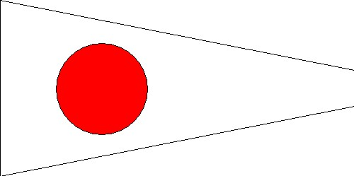

HRYRA PHRF 1
(Numerical Pennant 1)
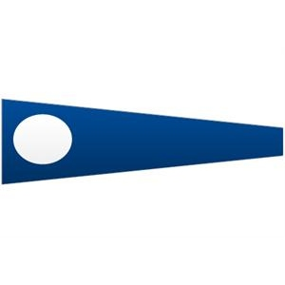

HRYRA PHRF 2
(Numerical Pennant 2)

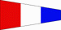

HRYRA PHRF 3
(Numerical Pennant 3)

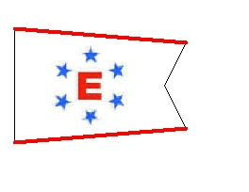

Ensign Fleet

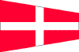

HRYRA PHRF 4
(Numerical Pennant 4)

Open Fleet
(Yellow Flag)

- Courses: Course numbers will be posted on the Race Committee Boat.
Sunday Courses | HRYRA  PHRF 1,2,3 | HRYRA PHRF 4,Open Fleet, Ensigns | Marks  To
1 | DW-DW | DW-DW | P
2 | DIF | DIW | P
3 | DIF-DF | DIW-DW | P
4 | DIF-DIF | DIF-DW | P
5 | DIG-DIF | DIF-DIF | P
6 | DJF | DJW | P
7 | DJF-DF | DJW-DW | P
8 | DJF-DJF | DJW-DJW | P
9 | CIF-DIF | CIF | P
10 | WD-WD | WD-WD | P
11 | FID | WID | S
12 | FD-FD | FD-WD | P
13 | FID-FD | WID-WD | S
14 | FID-FID | FID-WD | S
16 | GID-FD | FID-FD | S
17 | GID-FID | FID-FID | S
18 | JDF-DF | JDF-DW | S
19 | JDF-JDF | JDF-JDW | S
20 | JDG-JDF | JDF-JDW | S
21 | FIDW | WIYW | S
22 | DIFD | DIWD | P
23 | FYF | WYF | P
Saturday  Courses | HRYRA PHRF 1,2,3 | HRYRA PHRF 4,Open, Ensign | Marks to
W2 | O-F | Y-F | P
W4 | O-W-O-F | Y-W-Y-F | P
W6 | O-W-O-W-O-F | Y-W-Y-W-Y-F | P
T2 | O-Y-W-O-F | O-Y-W-O-F | P

O=Orange Tetrahedron(Large)
W=White Tetrahedron(Large)
Y=Yellow Tetrahedron(Large)
F=Finish.Line**the finish line will be between the RCboat and the YELLOW Cylinder
Course.board.diagram: (on back of RC Boat)
Fleet 1,2,3 | Fleet 4,Open,Ensign
course | course
bearing | bearing
distance | distance

W Courses:

Windward.mark

Leeward.mark

Start……………………..finish
